5.24 spatial database
1. add new database in pgadmin III: China
2. add a new extension of postgis. after that, a new table of coordinates definition will be automatically added into database
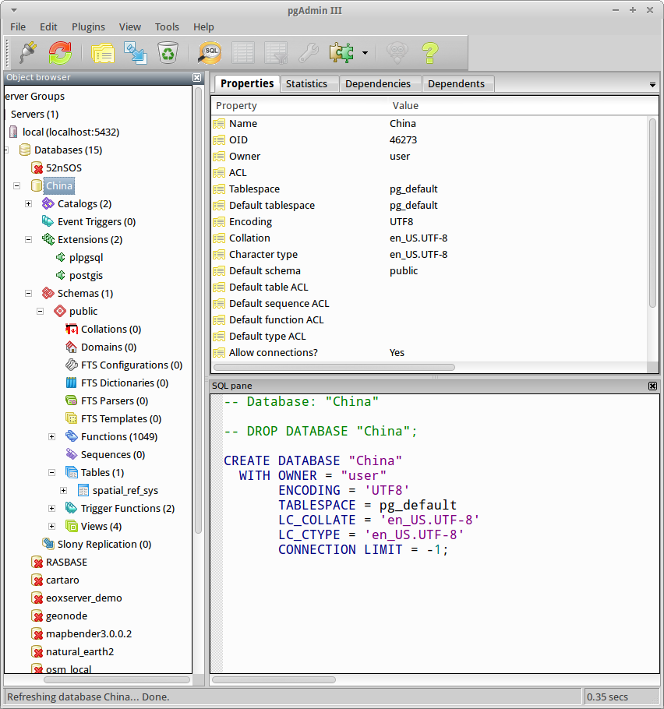
3. import data into ‘China’ database
use command below:
﻿ogr2ogr -overwrite -f "PostgreSQL" PG:"host=localhost user=user dbname=China password=user" -s_srs EPSG:4326 -t_srs EPSG:4497 -nlt MULTIPOLYGON CHN_adm3.shp
ogr2ogr -overwrite -f "PostgreSQL" PG:"host=localhost user=user dbname=China password=user" -s_srs EPSG:4326 -t_srs EPSG:4497 points.shp
ogr2ogr -overwrite -f "PostgreSQL" PG:"host=localhost user=user dbname=China password=user" -s_srs EPSG:4326 -t_srs EPSG:4497 buildings.shp

4. query

